Release Assembly - TC Cockpit Misc Bug Fixes Deployment Guide

Revision History
Author | Revision Number | Date
TCSASSEMBLER | 1.0 | 9/13th/2013

Deployment Instructions 3
1. Organization of Submission 3
2. Application Setup 3
2.1 Ant .Properties File 3
2.2 Configurations 3
2.3 Build Scripts Setup 3
3. Database Setup 4
4. Deployment Instructions 4
5. Starting 4
6. Verification 4
6.1 Before starting verification 4
6.2 Verification steps 4
7. Resource Contact List 18

Deployment Instructions

Organization of Submission

The submission follows directory structure provided below:

doc
Contains the Deployment Guide Document of this assembly.

Direct (https://coder.topcoder.com/tcs/clients/cronos/applications/direct/trunk revision 233604)
Contains sources and static files for Direct web application. This directory replicates the application development distribution structure and includes only updated and new files.
test_files
Contains the SQL files to insert test data and the test submissions for copilot posting
- 80001_80003_80001.zip
- 80001_80004_80002.zip
- 80001_80005_80003.zip

Application Setup

The application is expected to be deployed to the following environment:

JRE 1.5
JBoss 4.2.3.GA
Informix DS 11.5

Ant .Properties File

Configurations

N/A

Build Scripts Setup
The ANT build script for Direct application (build.xml) provides the following targets which are to be used:

- switch-and-checkout – checkout or switch to the defined source code branches for all components defined in subprojects.xml
- dist-backend – rebuilt all the components from the source code.
- first_deploy – must be the first task to execute from command line. It will copy all dependencies to your local JBoss folder.
- deploy – should be the main task to execute from command line. It will build and deploy WAR file.
- deploy-static-files – deploys the static files to JBOSS.
- deploy-apache-static – deploys the static files to apache server on VM.

Please refer here for more information:
http://www.topcoder.com/wiki/display/docs/TC+Direct+Setup+Guide

Database Setup
N/A

Deployment Instructions

This section provides the instructions in Production environment.

- Merge the code from submission into SVN for Direct application
- Run ant dist-backend to rebuild all the backend components (if you want, as there are no component updated in the assembly, but it’s good to make sure the backend components are built with latest codes)
- Build and deploy Direct application using ant deploy (or ant first_deploy) command.
- Copy static files using ant deploy-static-files command or ant deploy-apache-static if use apache as static file server.

Starting

- Shutdown the running JBoss server
- Build and deploy the Direct application
- Start JBoss server instance hosting Direct application

Verification

Before starting verification
Set up test data first, run the following SQL scripts in order against the test server database:
- test_files/test_data.sql

Use various browsers to open the link http://localhost:8180/direct or https://[vm_ip]/direct/ , login as heffan / password.

Verification steps

Verify TCCC-3857 cockpit forum links

Go to a studio contest

Clicks the Forum links to see if they open in a new window

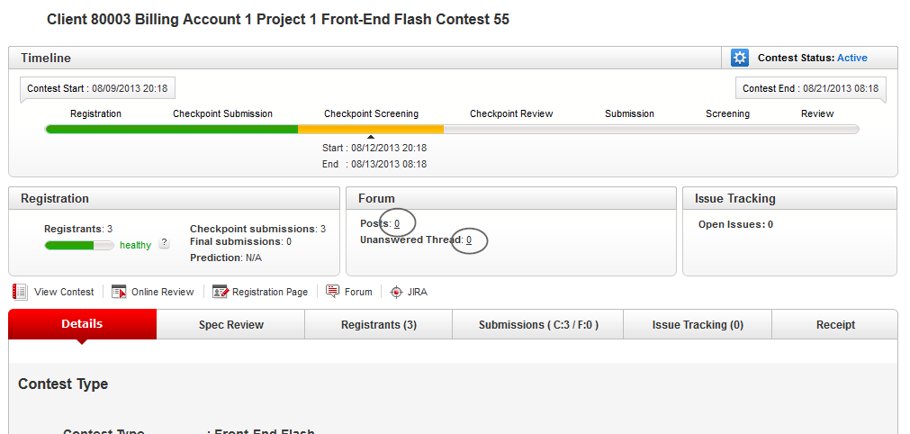

Go to a software contest, check the same stuff

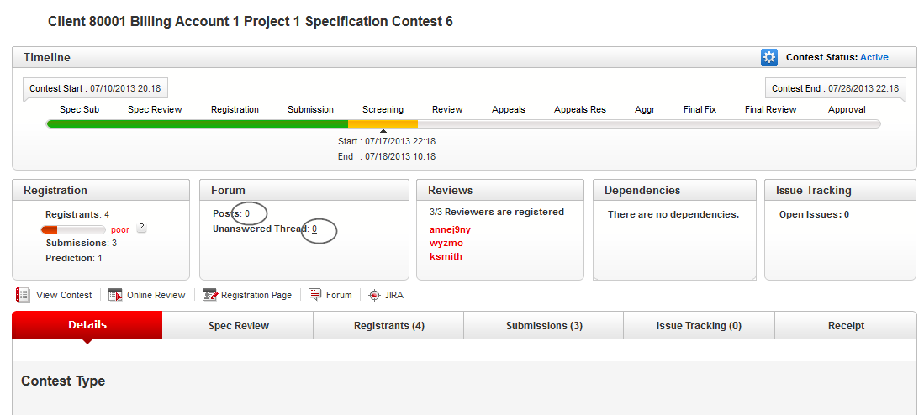

Go to a copilot posting contest, check the same stuff

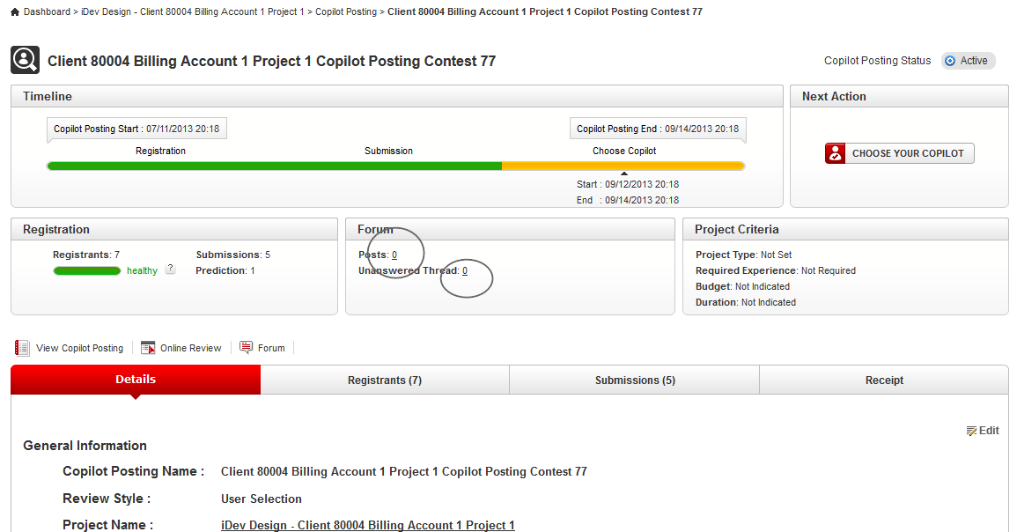

Verify TCCC-3914 My Copilot Postings Sorting
Go to my copilot postings page direct/copilot/listCopilotPostings.action

Go to /direct/copilot/postACopilot.action to add more draft contest postings with different names, lower case and upper case

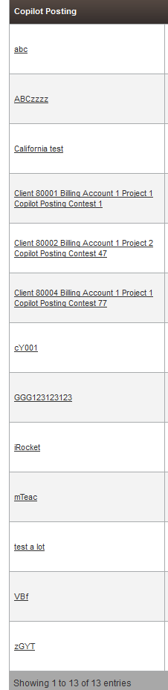

Click again

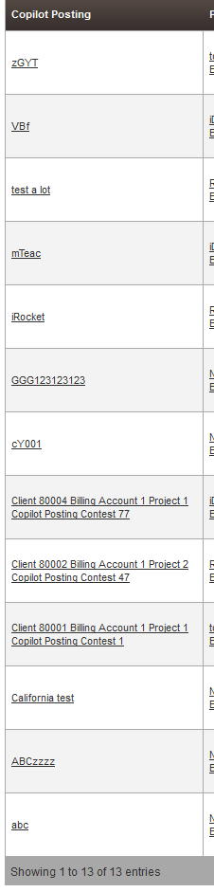

Check other columns accordingly

Verify TCCC-5110 Feedback - Copilot Contest Update Suggestion

Go to the [HOST] /direct/copilot/listCopilotContestSubmissions.action?projectId=80001

This contest is a completed copilot posting with 3 submissions.

Copy the submission files in the test_files directory to the /home/direct/temp_files
- 80001_80003_80001.zip
- 80001_80004_80002.zip
- 80001_80005_80003.zip

The submission test_files zip files should be copied after the application is started, otherwise it gets deleted by the system

In the submissions page, first try downloading each submission separately

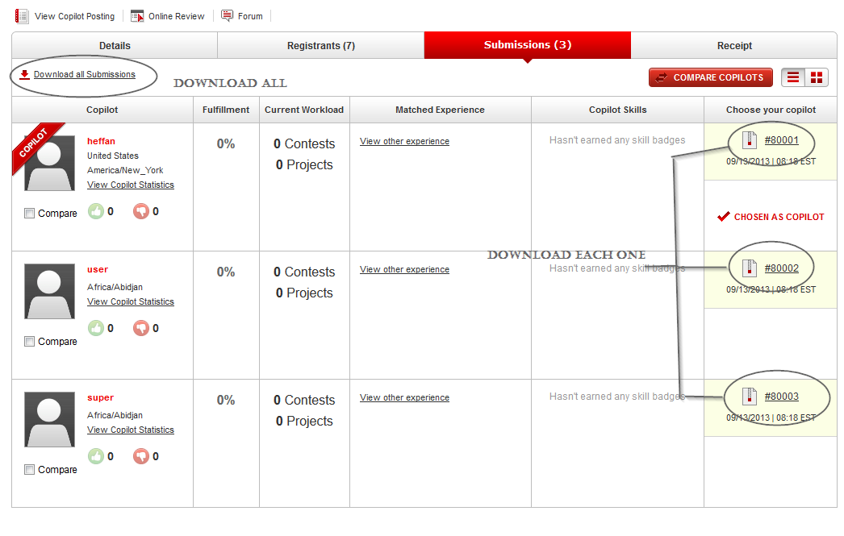

For each one download

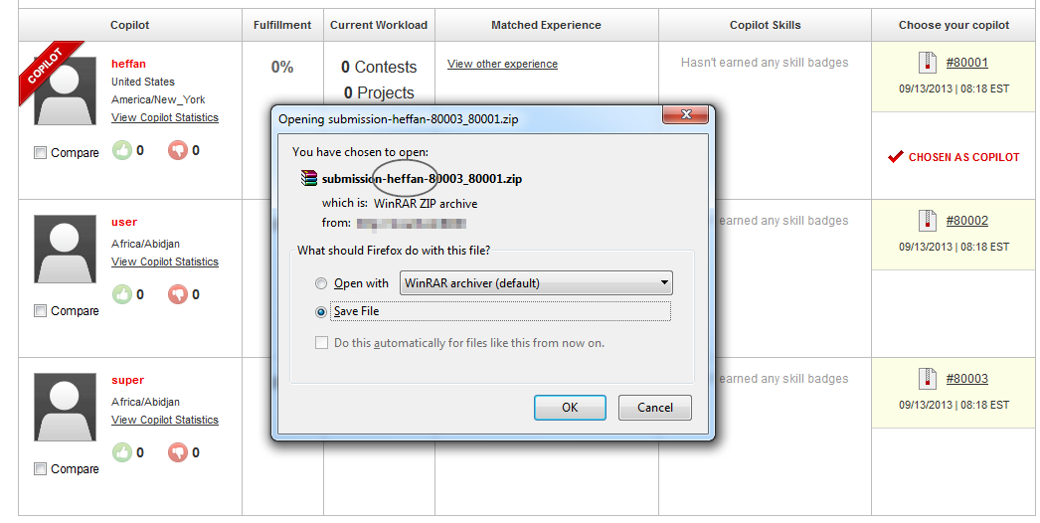

Submission name itself contain the submitter handle

Open the submission

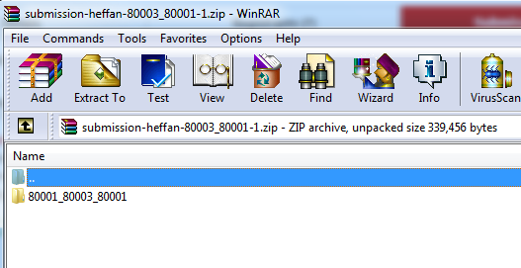

Go to the directory

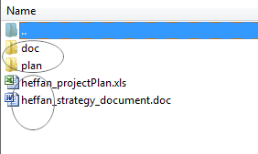

- The file are prefixed with the user handle
- The directory names are not

Go to directory doc and plan, you see

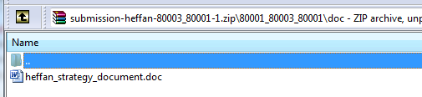

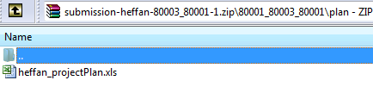

Files inside are also renamed

Try downloading all link

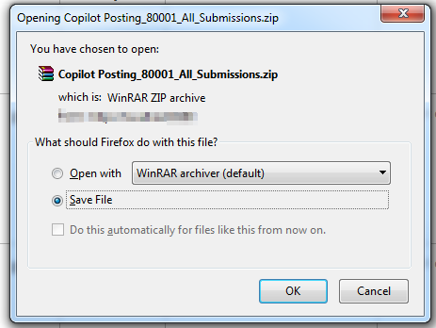

Open the archive

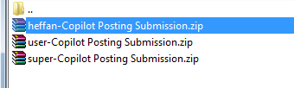

Open each

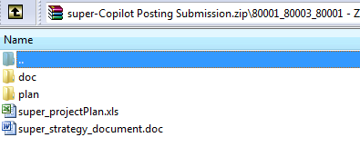

Verify TCCC-5160 Add duration in game plan when hovering on contest.

Go to a project’s game plan page

Hovering over each contest to check durations

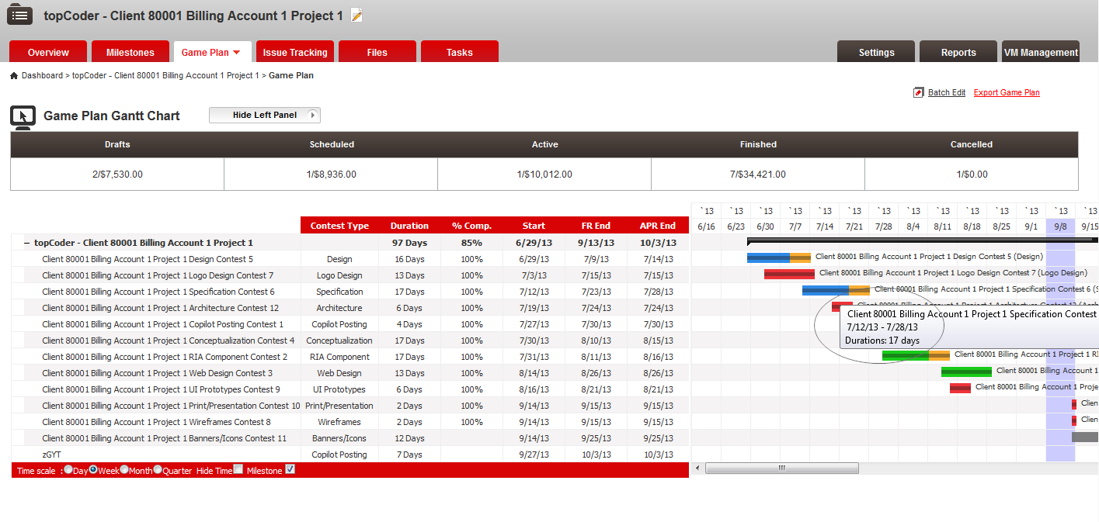

Verify TCCC-5275 Spelling issue on Post Mortem phase

This issue has been fixed, so no fix in this assembly.

You can verify by searching every files under the direct trunk with the typo ‘Post Motem’ and it does not exist in any file now

Verify TCCC-5437 Sorting on Customers in Cockpit

This issue has already been solve in https://apps.topcoder.com/bugs/browse/BUGR-8936

See OPS-19

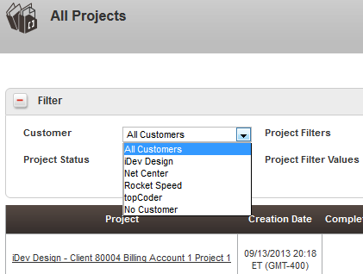

Verify TCCC-5605 Error Reading Direct News Feed on Cockpit Login Page

This one is dropped out of the scope in contest forum by PM:
http://apps.topcoder.com/forums/?module=Thread&threadID=798619

Verify https://apps.topcoder.com/bugs/browse/TCCC-5616

Go the right sidebar and hover over the status icon

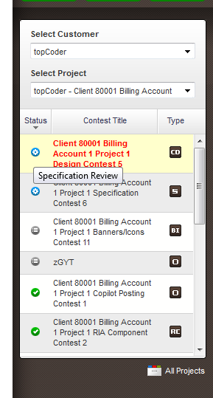

Hover over the contest type icon

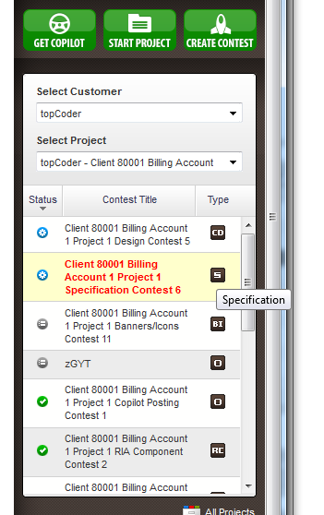

Verify https://apps.topcoder.com/bugs/browse/TCCC-5622

Go a project overview page and hover over the game plan tab

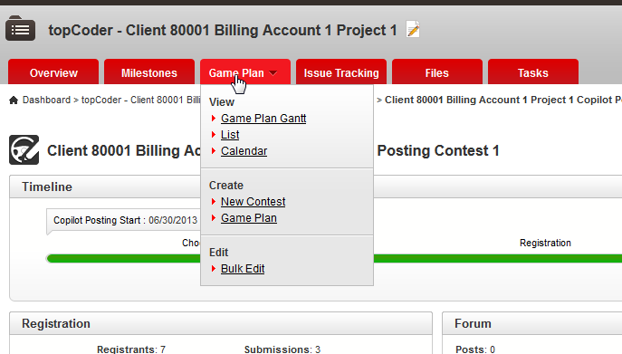

Click the tab to go to game plan page

Verify https://apps.topcoder.com/bugs/browse/TCCC-5633

Go to edit project page of a project

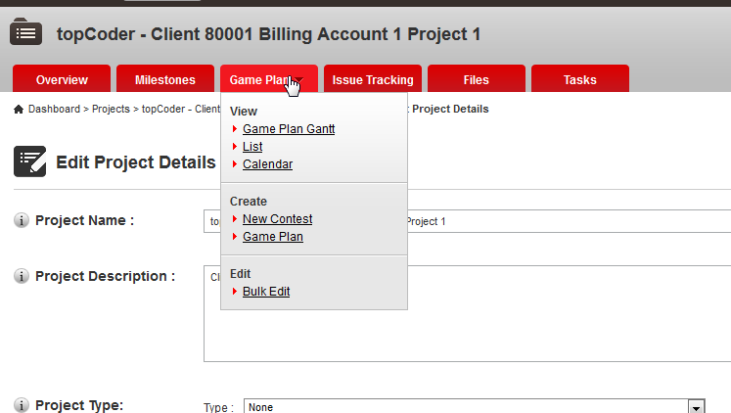

Resource Contact List

Name | Resource Email
TCSASSEMBLER

